**Learn Food ordering app**

**Bootstrap parts**

Flex box

<header className="header">

                <Container>

                    <div className="nav__wrapper">

                        <div className="logo">

                            <img src={logo} alt="logo" />

                            <h5>Tasty Treats</h5>

                        </div>

                        {/* Menu item goes here */}

                        <div className="navigation">

                            <div className="menu">

                                {

nav__links.map((nav, index) => (

                                        <NavLink to={nav.path} key={index}>

                                            {nav.display}

                                        </NavLink>

                                    ))

                                }

                            </div>

                        </div>

                        {/* Nav right Icons */}

                        <div className="nav__right">

                            <span className="cart__icon">

                                <i class="ri-shopping-cart-line">

                                    <span className="cart__badge">2</span>

                                </i>

                            </span>

                            <span className="user">

                                <Link to='/login'>

                                    <i class="ri-user-line"></i>

                                </Link>

                            </span>

                            <span className="mobile__menu">

                                <i class="ri-menu-line"></i>

                            </span>

                        </div>

                    </div>

                </Container>

            </header>



After flex box class name, child element of attributes are oriented based on row (default)

<div className="nav__wrapper d-flex ">

<Logo>

<Nav Bar>

<Icons>

</div >

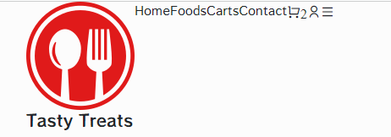

Child elements of the tags are by default subjected in row.

**To Evenly arrange the child elements**

<div className="nav__wrapper d-flex justify-content-between">

<Logo>

<Nav Bar>

<Icons>

</div >



Here items are justified with item being on equally space between

**To align all the child element on center with respect to both row and column**

<div className=" nav__wrapper d-flex justify-content-between align-items-center

<Logo>

<Nav Bar>

<Icons>

</div >

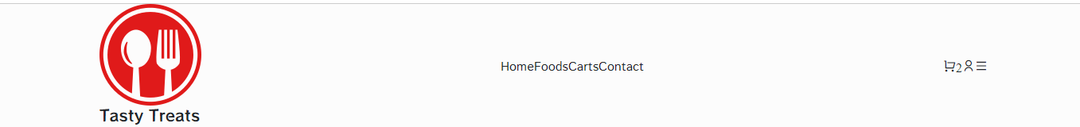

Here items are justified with item being on equally space between as well as all the elements of the child elements are automatically align on center (both with respect to row and column)

**To arrange the Nav items similar to above**

<div className="navigation">

              <div className="menu d-flex align-items-center gap-5">

                                {

                                    nav__links.map((nav, index) => (

                                        <NavLink to={nav.path} key={index}>

                                            {nav.display}

                                        </NavLink>

                                    ))

                                }

                            </div>

                </div>



Here child element of menu (nav bar items) are assigned with flex box (default=row) and items are align on center with respect to row and column with equal gap of gap=5.



Adding CSS

Side with css

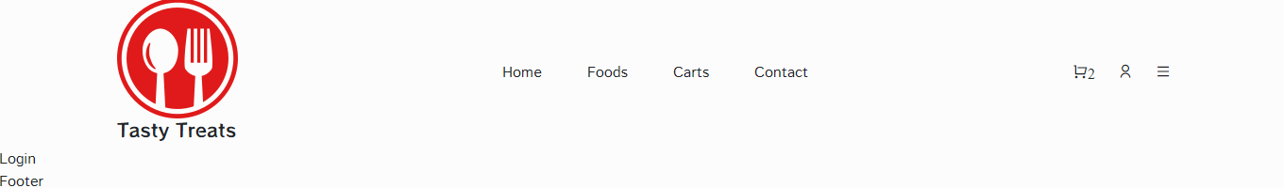

Header.css

The line-height property specifies the height of a line. Note: Negative values are not allowed. The line-height CSS property sets the height of a line box. It's commonly used to set the distance between lines of text. On block-level elements, it specifies the minimum height of line boxes within the element. It is similar to line spacing on word;

.header {

    width: 100%;

    height: 80px;

    line-height: 80px;

}

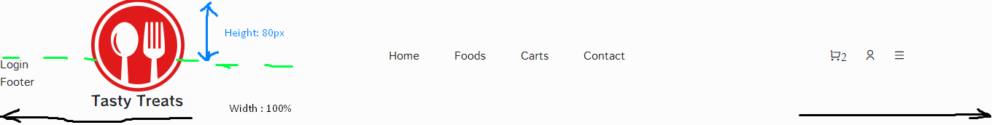

**CSS for logo**

.logo {

    align-items: center;

}

.logo img {

    width: calc(100% - 60%);

    object-fit: contain;

}

.logo h5 {

    font-weight: 600;

    font-size: 1rem;

    color: #212245;

    margin-top: -10px;

    margin-bottom: 0px;

}



Css for Nav Bar

.menu a {

    font-weight: 600;

    font-size: 1rem;

    color: #212245;

}

.menu a:hover {

    color: #df2020;}



**Highlight which Navlink is active**

A <NavLink> is a special kind of <Link> that knows whether or not it is "active" or "pending". This is useful when building a navigation menu, such as a breadcrumb or a set of tabs where you'd like to show which of them is currently selected. It also provides useful context for assistive technology like screen readers.

The className prop works like a normal className, but you can also pass it a function to customize the classNames applied based on the active and pending state of the link.

You can pass a render prop as children to customize the content of the <NavLink> based on the active and pending state, which is useful to change styles on internal elements

{

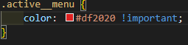      nav__links.map((nav, index) => (

         <NavLink

           to={nav.path}

           key={index}

         className={isActive => isActive ? 'active__menu':''}>

                   {nav.display}

  </NavLink>

                                    ))

                                }

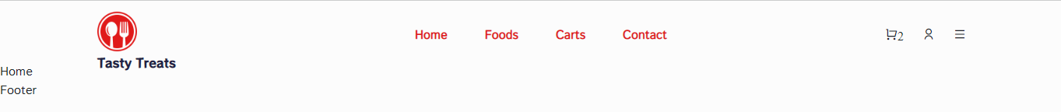

In such case all the Navlink items get highlight because the code doesn’t specify which Navlink is active. For such case, the active NavLink can be pointed using a callback element.

{

      nav__links.map((nav, index) => (

         <NavLink

           to={nav.path}

           key={index}

         className={navlink => navlink.isActive ? 'active__menu':''}>

                   {nav.display}

  </NavLink>

                                    ))

                                }



**Absolute VS Relative Position CSS**

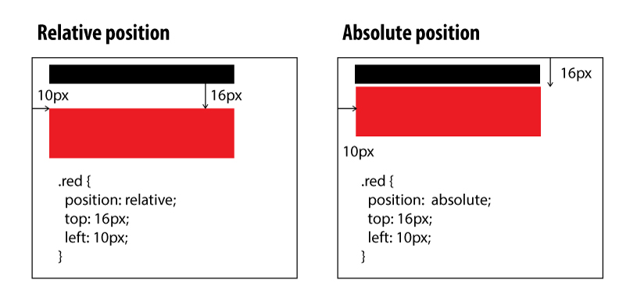Relative - the element is positioned relative to its normal position. An element with position: relative; is positioned relative to its normal position. Setting the top, right, bottom, and left properties of a relatively-positioned element will cause it to be adjusted away from its normal position. Other content will not be adjusted to fit into any gap left by the element.

Absolute - the element is positioned absolutely to its first positioned parent. An element with position: absolute; is positioned relative to the nearest positioned ancestor (instead of positioned relative to the viewport, like fixed). However; if an absolute positioned element has no positioned ancestors, it uses the document body, and moves along with page scrolling. Note: Absolute positioned elements are removed from the normal flow, and can overlap elements.

.cart__icon {

    position: relative;

}

.cart__badge {

    position: absolute;

    top: 20px;

    right: -10px;

    background: #df2020;

    color: #fff;

    width: 15px;

    height: 15px;

    border-radius: 50%;

    font-size: 0.8rem;

    font-weight: 500;

    display: flex;

    align-items: center;

    justify-content: center;

}



Adding Mobile view for Media-query

@media only screen and (max-width:700px) {

    .navigaton {

        position: fixed;

        top: 0;

        left: 0;

        width: 100%;

        height: 100%;

        background: rgba(0, 0, 0, 0.425);

        z-index: 99;

    }

}

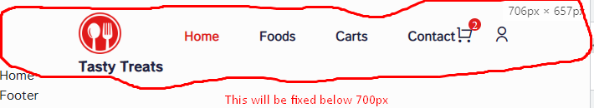

To change the position of elements on mobile view, use absolute view

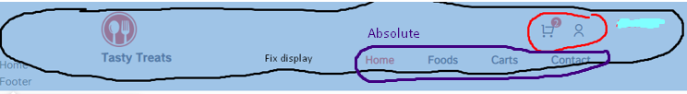

@media only screen and (max-width:992px) {

    .navigaton {

        position: fixed;

        top: 0;

        left: 0;

        width: 100%;

        height: 100%;

        background: rgba(0, 0, 0, 0.425);

        z-index: 99;

    }

    .menu {

        position: absolute;

    }

}

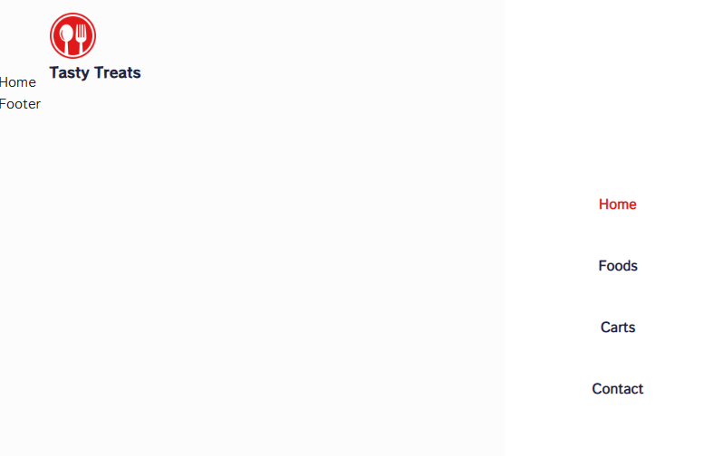

@media only screen and (max-width:992px) {

    .navigaton {

        position: fixed;

        top: 0;

        left: 0;

        width: 100%;

        height: 100%;

        background: rgba(0, 0, 0, 0.425);

        z-index: 99;

display: ‘none’

    }

    .menu {

        position: absolute;

        top: 0;

        right: 0;

        width: 250px;

        height: 100%;

        background: #fff;

        flex-direction: column;

        justify-content: center;

        align-items: center;

        z-index: 100;

        line-height: 20px;

    }

}

Toggle to make item visible based on click (Add/remove css class)

Here the code use reference to add particular class to that tags

div className="navigation" ref={menuRef} >

                            <div className="menu d-flex align-items-center gap-5">

                                {

                                    nav__links.map((nav, index) => (

                                        <NavLink

                                            to={nav.path}

                                            key={index}

                                            className={navClass => navClass.isActive ? 'active__menu':''}

                                            onClick={toggleMenu}

                                            >

                                            {nav.display}

                                        </NavLink>

                                    ))

                                }

                            </div>

                        </div>

Delcare useReference above to add class

    const menuRef = useRef();

    const toggleMenu = () => menuRef.current.classList.toggle('show__menu')

**To get the class name of an element:**

Access the element's class name as “event.currentTarget.className”

Example to check it particular tag has class or not

    const handleClick = event => {

      console.log('className 👉️', event.currentTarget.className);

      if (event.currentTarget.classList.contains('my-class')) {

        console.log('Element contains class');

      } else {

        console.log('Element does NOT contain class');

      }

    };

When the use clicks onClick={toggleMenu} then the function add/remove(toggles) the classname from css

Initially, the navbar is not visible

    .navigation {

        position: fixed;

        top: 0;

        left: 0;

        width: 100%;

        height: 100%;

        background: rgba(0, 0, 0, 0.425);

        z-index: 99;

        display: none;

    }

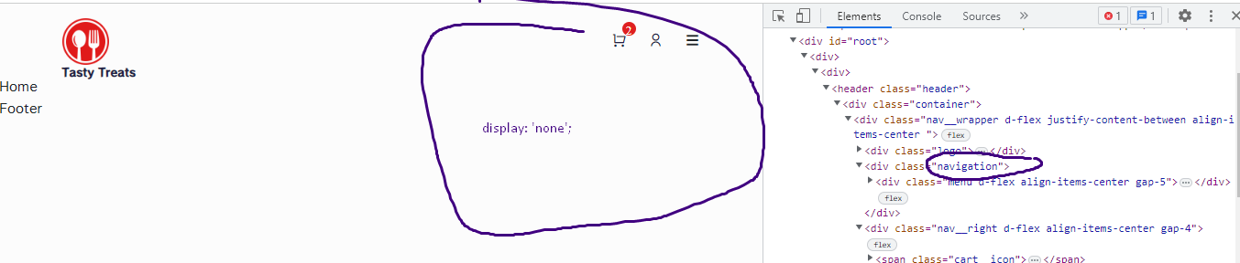

When user click on a specific onClick it toggle to add/remove class

 <span className="mobile__menu" onClick={toggleMenu}>

                                <i class="ri-menu-line"></i>

                            </span>

Initially navigation has no display

div className="navigation" ref={menuRef} >

                            <div className="menu d-flex align-items-center gap-5">

CSS of naviagation

    .navigation {

        position: fixed;

        top: 0;

        left: 0;

        width: 100%;

        height: 100%;

        background: rgba(0, 0, 0, 0.425);

        z-index: 99;

        display: none;

    }

After click, it add a particular class on reference part which has display as block attribute

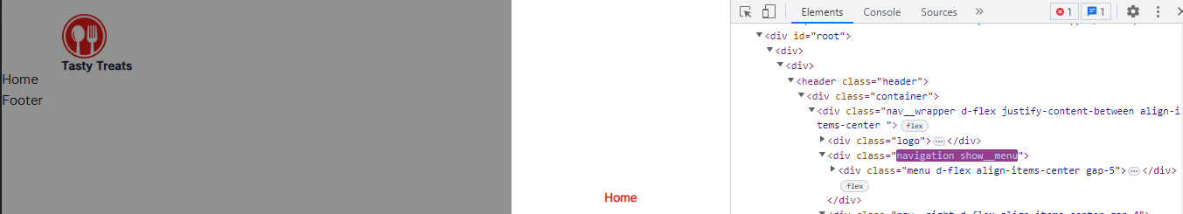

    .show__menu {

        display: block;

    }

}

On click add class show__menu on the reference part

const menuRef = useRef();

    const toggleMenu = () => menuRef.current.classList.toggle('show__menu')

Adding row, col, list group and list items

Row and Column

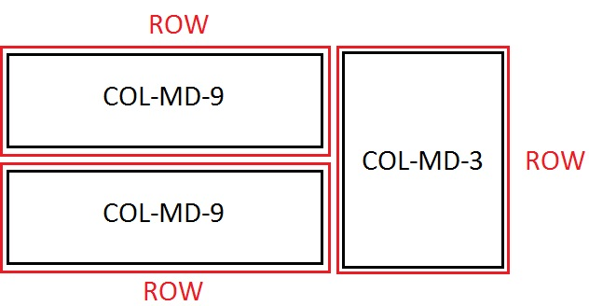

 <Container>

        <Row>

          <Col lg='3' md='4' sm='6'>1</Col>

<Col lg='3' md='4' sm='6'>2</Col>

<Col lg='3' md='4' sm='6'>3</Col>

<Col lg='3' md='4' sm='6'>4</Col>

  </Row>

</Container>

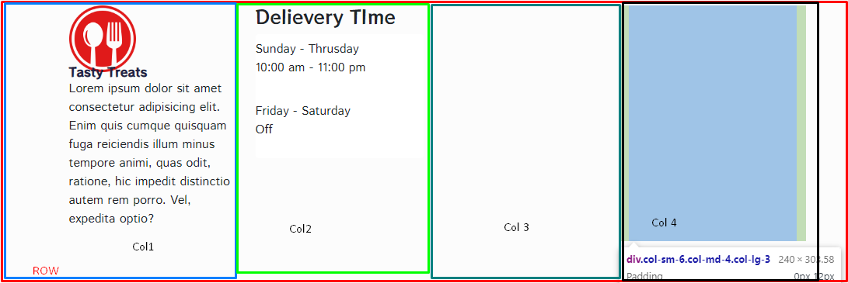

List groups

List groups are a flexible and powerful component for displaying a series of content. Modify and extend them to support just about any content within.

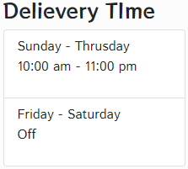<ListGroup>

              <ListGroupItem className='border-0 ps-0'>

                <span>Sunday - Thrusday</span>

                <p>10:00 am - 11:00 pm</p>

              </ListGroupItem>

              <ListGroupItem className='border-0 ps-0'>

                <span>Friday - Saturday</span>

                <p>Off</p>

              </ListGroupItem>

</ListGroup>

To remove the border and change spacing, border and ps are used on classname with appropriate size.

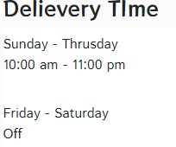 <ListGroup>

              <ListGroupItem className='border-0 ps-0'>

                <span>Sunday - Thrusday</span>

                <p>10:00 am - 11:00 pm</p>

              </ListGroupItem>

              <ListGroupItem className='border-0 ps-0'>

                <span>Friday - Saturday</span>

                <p>Off</p>

              </ListGroupItem>

            </ListGroup>

For transition effect

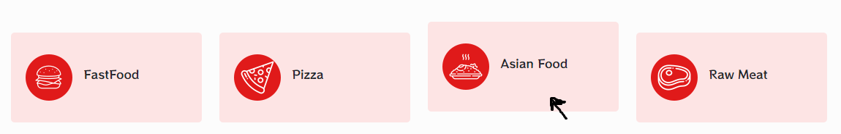

.category__item {

    background: #fde4e4;

    padding: 30px 20px;

    border-radius: 5px;

    cursor: pointer;

    align-items: center;

    transition: 0.4s;

}

.category__item:hover {

    transform: translateY(-15px);

}

The transform helps to translate the element to Y direction with transition time response of 0.4s

**Store item to State using useState()**

useState is a React Hook that lets you add a state variable to your component.

import { useState } from 'react';

const [state, setState] = useState(initialState);

**useState(initialState)**

Call useState at the top level of your component to declare a state variable. useState returns an array with exactly two values:

* The current state. During the first render, it will match the initialState you have passed.
* The set function that lets you update the state to a different value and trigger a re-render. The value that you want the state to be. It can be a value of any type, but there is a special behavior for functions. If you pass a function as **setState**, it will be treated as an updater function. It must be pure, should take the pending state as its only argument, and should return the next state. React will put your updater function in a queue and re-render your component. During the next render, React will calculate the next state by applying all of the queued updaters to the previous state.

set functions do not have a return value.

import React, { useState } from 'react';

const [ category, setCategory ] = useState('ALL');

const [ allproduct, setAllProduct ] = useState(products);

const clickBurger ={() => setCategory('BURGER')} //Sets category as ‘BURGER’

if(category === 'BURGER') {

      const filteredProducts = products.filter(item => item.category === 'Burger');

      setAllProduct(filteredProducts); //SetProduct as filtered item i.e ‘Burger’

    }

**Update state value on 1st run, on state update and its effect on other state on each Render using useEffect()**

The useEffect Hook allows to perform side effects in the components. Some examples of side effects are: fetching data, directly updating the DOM, and timers. useEffect accepts two arguments. The second argument is optional.

useEffect(<function>, <dependency>)

useEffect runs on every render. That means that when the value on page changes, a render happens, which then triggers another effect. There are several ways to control when side effects run.

### 1. No dependency passed:

useEffect(() => {

//Runs on every render

});

### 2. An empty array:

useEffect(() => {

//Runs only on the first render

}, []);

### 3. Props or state values:

useEffect(() => {

//Runs on the first render

//And any time any dependency value changes

}, [prop, state]);

import React, { useState, useEffect } from 'react';

useEffect(() => {

    if(category === 'ALL') {

      setAllProduct(products);

    }

    if(category === 'BURGER') {

      const filteredProducts = products.filter(item => item.category === 'Burger');

      setAllProduct(filteredProducts);

    }

    if(category === 'PIZZA') {

      const filteredProducts = products.filter(item => item.category === 'Pizza');

      setAllProduct(filteredProducts);

    }

    if(category === 'BREAD') {

      const filteredProducts = products.filter(item => item.category === 'Bread');

      setAllProduct(filteredProducts);

    }

  }, [category])

Initially at start (first render), the state is set to Product. The dependencies variable [category] states that on each state change of category state, the component will render and update.

You need to pass two arguments to useEffect:

1. A setup function with setup code that connects to that system.
   1. It should return a cleanup function with cleanup code that disconnects from that system.
2. A list of dependencies including every value from your component used inside of those functions.

React calls your setup and cleanup functions whenever it’s necessary, which may happen multiple times:

1. Your setup code runs when your component is added to the page (mounts).
2. After every re-render of your component where the dependencies have changed:
   * First, your cleanup code runs with the old props and state.
   * Then, your setup code runs with the new props and state.
3. Your cleanup code runs one final time after your component is removed from the page (unmounts).

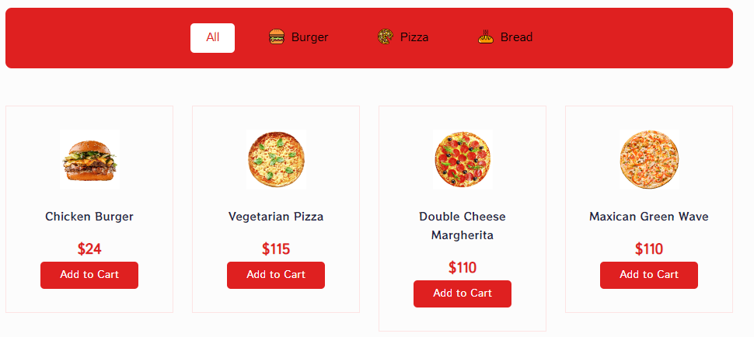

When category is set to ‘ALL’

Similary to dynamically update css tags and attribute

<div className="food__category d-flex align-item-center justify-content-center gap-4">

       <button className={`all__btn ${category === 'ALL' ? 'foodBtnActice' : ''}`} onClick={() => setCategory('ALL')}>All</button>

       <button className={`d-flex align-item-center gap-2 ${category === 'BURGER' ? 'foodBtnActice' : ''}`} onClick={() => setCategory('BURGER')}><img src={foodCategoryImg01} alt="" />Burger</button>

<button className={`d-flex align-item-center gap-2 ${category === 'PIZZA' ? 'foodBtnActice' : ''}`} onClick={() => setCategory('PIZZA')}><img src={foodCategoryImg02} alt="" />Pizza</button>

       <button className={`d-flex align-item-center gap-2 ${category === 'BREAD' ? 'foodBtnActice' : ''}`} onClick={() => setCategory('BREAD')} ><img src={foodCategoryImg03} alt="" />Bread</button>                    </div>

The above code states it the category ss “something” or the category component state is active run ‘foodBtnActive’ attribute.

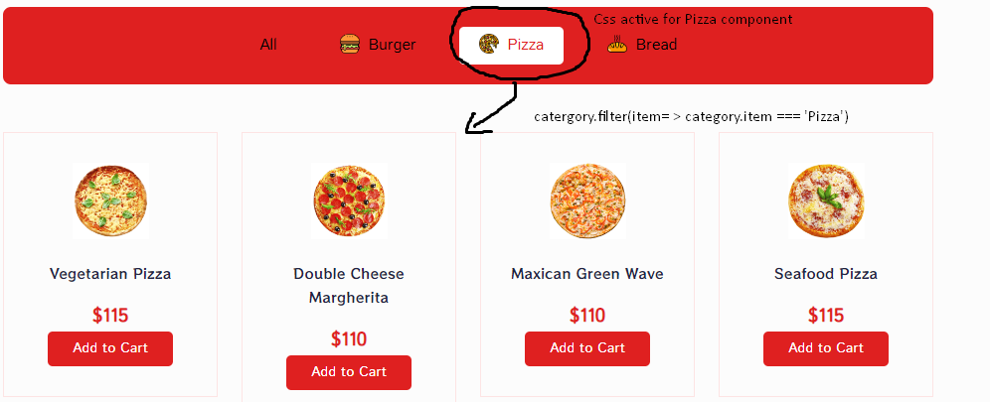

Bootstrap Grid System with col and row

Bootstrap’s grid system uses a series of containers, rows, and columns to layout and align content. It’s built with flexbox and is fully responsive. Below is an example and an in-depth look at how the grid comes together.

<div class="container">

  <div class="row">

    <div class="col">

      1 of 2

    </div>

    <div class="col">

      2 of 2

    </div>

  </div>

</div>

Adding size parameter with Grid

Auto-layout for flexbox grid columns also means you can set the width of one column and have the sibling columns automatically resize around it. You may use predefined grid classes (as shown below), grid mixins, or inline widths. Note that the other columns will resize no matter the width of the center column. Rows are wrappers for columns. Each column has horizontal padding (called a gutter) for controlling the space between them. This padding is then counteracted on the rows with negative margins. This way, all the content in your columns is visually aligned down the left side. In a grid layout, content must be placed within columns and only columns may be immediate children of rows. Thanks to flexbox, grid columns without a specified width will automatically layout as equal width columns.

For example, four instances of .col-sm will each automatically be 25% wide from the small breakpoint and up. Column classes indicate the number of columns you’d like to use out of the possible 12 per row. So, if you want three equal-width columns across, you can use .col-4.

Without Size Parameter

<Container>

            <Row>

              <Col lg='6' md='6'>

                  <img src={whyImage} alt="why tasty treats" />

              </Col>

              <Col lg='6' md='6'>

                  <div className="why__tasty-treat">

                    <h2 className="tasty_treat-title">

                      Why Tasty treat

                    </h2>

                    <p>Lorem ipsum dolor sit,</p>

                    <ListGroup>

                      <ListGroupItem>

                        <p>

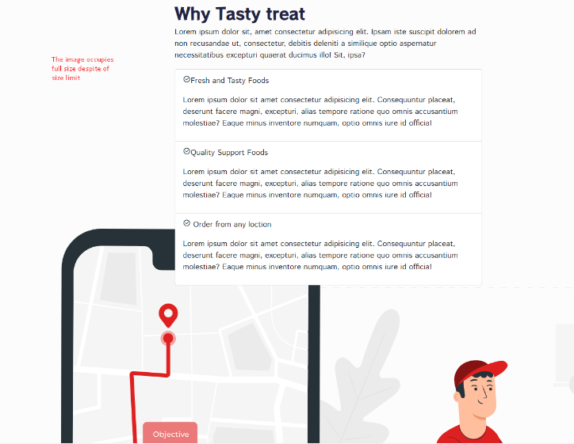

<i class="ri-checkbox-circle-line">

</i>

Fresh and Tasty Foods

                     </p>

                        <p>Lorem </p>

                      </ListGroupItem>

                    </ListGroup>

                  </div>

              </Col>

            </Row>

          </Container>

With Size specifically assigned

<Container>

            <Row>

              <Col lg='6' md='6'>

                  <img src={whyImage} alt="why tasty treats" />

              </Col>

              <Col lg='6' md='6'>

                  <div className="why__tasty-treat">

                    <h2 className="tasty_treat-title">

                      Why Tasty treat

                    </h2>

                    <p>Lorem ipsum dolor sit,</p>

                    <ListGroup>

                      <ListGroupItem>

                        <p>

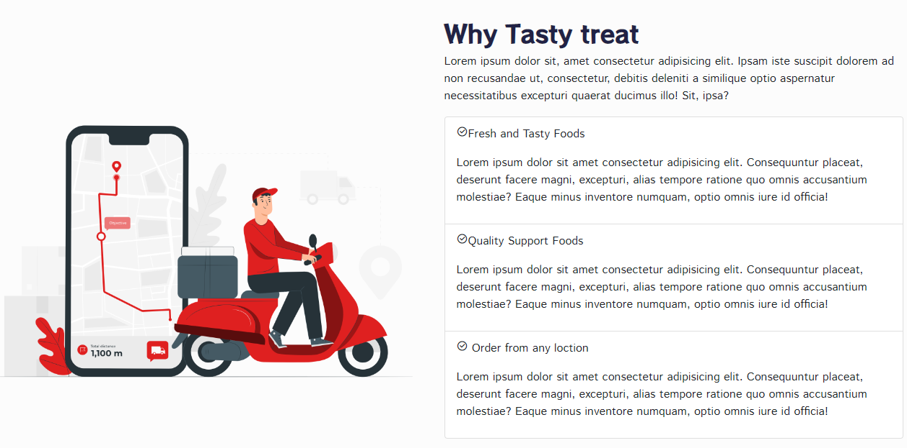

<i class="ri-checkbox-circle-line">

</i>

Fresh and Tasty Foods

                     </p>

                        <p>Lorem </p>

                      </ListGroupItem>

                    </ListGroup>

                  </div>

              </Col>

            </Row>

          </Container>

**To track scroll and hover header through out the page using useRef()**

import React, { useEffect } from 'react';

const headerRef = useRef();

    useEffect(() => {

        window.addEventListener('scroll', () => {

            if(document.body.scrollTop > 80 || document.documentElement.scrollTop >80 ) {

                headerRef.current.classList.add('header__shrink');

            }

            else {

                headerRef.current.classList.remove('header__shrink');

            }

        })

        return () => window.removeEventListener('scroll')

    }, [])

    return (

        <>

            <header className="header" ref={headerRef}

………..

</header>

Css

.header__shrink {

    position: sticky;

    top: 0;

    left: 0;

    background: #fff;

    z-index: 999;

    box-shadow: 5px 5px 15px -5px #fde4e5;

}

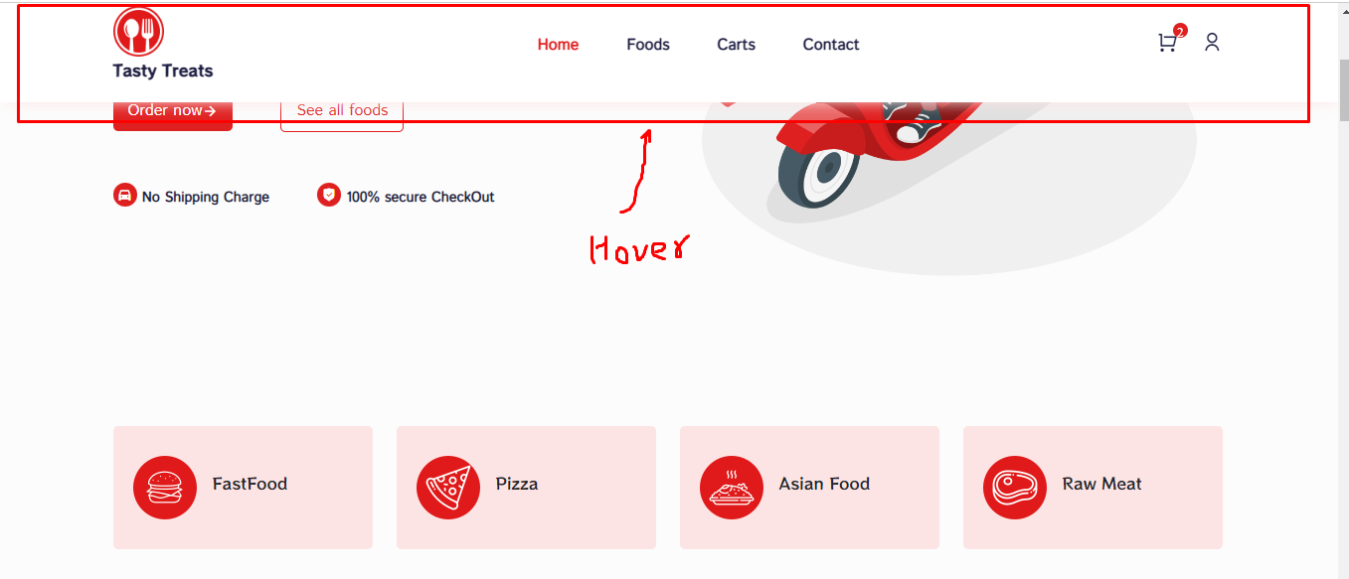

The onscroll event occurs when an element's scrollbar is being scrolled. In JavaScript, using the addEventListener() method:

*object*.addEventListener("scroll", *myScript*);

When you scroll a document or an element, the scroll events fire. You can trigger the scroll events in the following ways, for example:

* Using the scrollbar manually
* Using the mouse wheel
* Clicking an ID link
* Calling functions in JavaScript

To register a scroll event handler, you call the addEventListener() method on the target element, like this:

targetElement.addEventListener('scroll', (event) => {

*// handle the scroll event*

});

or assign an event handler to the onscroll property of the target element:

targetElement.onscroll = (event) => {

*// handle the scroll event*

};

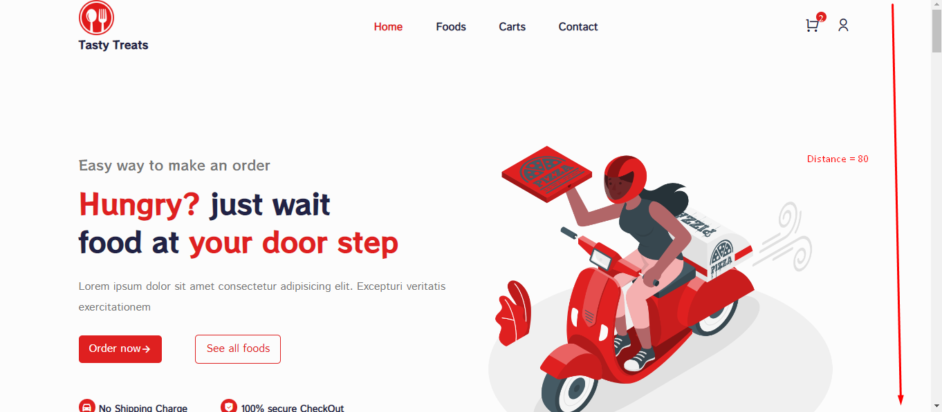

The Element.scrollTop property gets or sets the number of pixels that an element's content is scrolled vertically.

An element's scrollTop value is a measurement of the distance from the element's top to its topmost *visible* content. When an element's content does not generate a vertical scrollbar, then its scrollTop value is 0.

Currently the distance is 80. When the distance > 80 on scrolling, the css class gets attached and makes the whole header field sticky and move through out the webpage.

The way Redux works is simple. There is a central store that holds the entire state of the application. Each component can access the stored state without having to send down props from one component to another. There are three core components in Redux — actions, store, and reducers.

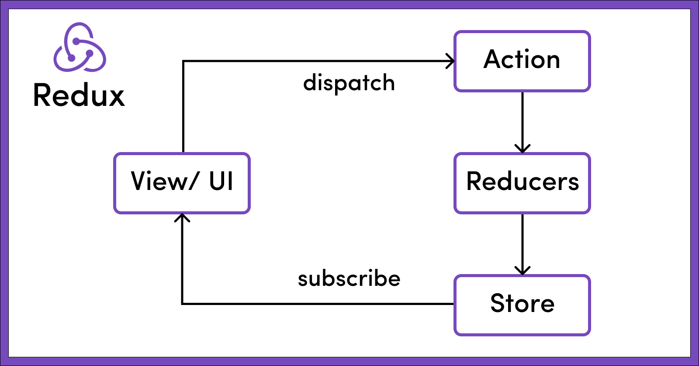

Redux is one of the most popular state management libraries in JavaScript, especially among React developers. Real-world applications need to perform more than just simple action dispatches. You need to enhance Redux’s capability using middleware libraries like Redux Thunk, Redux-Saga, and the recently released listener middleware to manage side effects and more complex synchronous and asynchronous processes. Since Redux Toolkit (RTK) became the de facto toolset for writing modern Redux code, it is accurate to say that Redux Thunk also became the default middleware, because it is part of RTK by default.

The benefit of Redux-Saga in comparison to Redux-Thunk is that you can more easily test your asynchronous data flow. Redux-Thunk, however, is great for small projects and for developers who just entered into the React ecosystem. The thunks’ logic is all contained inside of the function

createSlice: A function that accepts an initial state, an object full of reducer functions, and a "slice name", and automatically generates action creators and action types that correspond to the reducers and state.

createReducer: A utility that simplifies creating Redux reducer functions. It uses Immer internally to drastically simplify immutable update logic by writing "mutative" code in your reducers, and supports directly mapping specific action types to case reducer functions that will update the state when that action is dispatched.

An important statement:

Internally, createSlice uses createAction and createReducer, [...]

## 

## Main Features of Redux Tool Kit API

RTK APIs have several functions that help the Redux API function to exist. These functions help streamline the flow of the Redux rather than changing the flow. The different functions are-

### 1. cofigureStore

It will create the instance of the Redux store by just accepting a named object to automatically set up the Redux DevTools extension.

### 2. createAction

This function will accept the initial state's value and a lookup table of action types to perform better. It will then create an action for handling all the action types mentioned.

### 3. createReducer

This function will accept the value of the initial state and a lookup table of the action types to create a reducer for handling all types of actions.

### 4. Createslice

This function will accept the value of the initial state and a lookup table of reducer names and action creator function.

Actions are the object of JavaScript having type property. Not only this, but you can also include custom properties as per requirement. These properties describe what to do with the state but cannot change the state.

**Add cart element to page using reduxtoolkit**

createSlice.js

Fitst create a createSlice API function which accepts initial value and make a lookup table for available reducer name and action for the particular redux state

import { createSlice } from "@reduxjs/toolkit";

const initialState = {

    cartItems: [],

    totalQuantity: 0,

    totalAmount: 0

}

Here initial value of cart is 0. Initial Cart has 0 elements and as item adds to cart, item is appended to cart so cartItem should be array. A cart component has items which refers to quantity of item, amount of item, title and so-on. Cart consist of multiple elements so Quantity and amount as taken as total ie totalQuantity, totalAmount.

const cartSlice  = createSlice(

    {

        name: 'cart',

        initialState: initialState,

        reducers: {

            addItem(state, action) {

                const newItem = action.payload;

                const existingItem = state.cartItems.find(item => item.id === newItem.id)

                state.totalQuantity++;

                if(!existingItem) {

                    state.cartItems.push({

                        id:newItem.id,

                        title: newItem.title,

                        image01: newItem.image01,

                        price: newItem.price,

                        quantity: 1,

                        totalPrice: newItem.price,

                    })

                }

                else {

                    existingItem.quantity++;

                    existingItem.totalPrice = Number(existingItem.totalPrice) + Number(newItem.totalPrice)

                }

                state.totalAmount = state.cartItems.reduce((total, item) => (

                    total + Number(item.price) * Number(item.quantity)

                ))

            }

        }

    }

);

export const cartActions = cartSlice.actions;

export default cartSlice;

A cartSlice element listens to state and it’s action via name. In this case name is ‘cart’. If action is ‘cart’ then this code gets executes.

This particular cartSlice has action for addingItem using a callback addItem(state, action) where state hold both old, current and next state data whose action is to addItem to the cart.

Initially cartItem is 0. So every new action (when new item is added to cart) is taken as newItem = action.payload. Payload holds to data from other components. In case of same item in Cart, it’s not appended to array but the quantity of same item is incremented by one. To detect item on cart, id can be compared. Id can be use to determine if the item is already on cart. If new element doesn’t exist then the quantity of existing item is incremented by 1 (oldExistingitem.quantity + 1) and total price of existing item is added to one self. (oldExistingitem.price + newExistingitem.price).

If no new element is added. Array element is incremented by 1 i.e here totalQuantity is incremented by 1 and item is added to the array using push. (id, title, image, quanity and so-on which is treated as object).

Wherever the item gets added (new or existing), total price should be calculated. If sum be the totalPrice then as item added new sum becomes sum = sum + item which can be done by reduce function.

Here total refers to sum and item refers to new item added from components, then total amount becomes

Total = total + price_of_item * totalQuantity.

                state.totalAmount = state.cartItems.reduce((total, item) => (

                    total + Number(item.price) * Number(item.quantity)

**Array.prototype.reduce()**

The reduce() method executes a user-supplied "reducer" callback function on each element of the array, in order, passing in the return value from the calculation on the preceding element. The final result of running the reducer across all elements of the array is a single value. The first time that the callback is run there is no "return value of the previous calculation". If supplied, an initial value may be used in its place. Otherwise, the array element at index 0 is used as the initial value and iteration starts from the next element (index 1 instead of index 0).

const array1 = [1, 2, 3, 4];

// 0 + 1 + 2 + 3 + 4

const initialValue = 0;

const sumWithInitial = array1.reduce(

(accumulator, currentValue) => accumulator + currentValue,

initialValue

);

console.log(sumWithInitial);

// Expected output: 10

The reducer walks through the array element-by-element, at each step adding the current array value to the result from the previous step (this result is the running sum of all the previous steps) — until there are no more elements to add. The reduce() method is an iterative method. It runs a "reducer" callback function over all elements in the array, in ascending-index order, and accumulates them into a single value. Every time, the return value of callbackFn is passed into callbackFn again on next invocation as accumulator. The final value of accumulator (which is the value returned from callbackFn on the final iteration of the array) becomes the return value of reduce().

Store.js

Then create a store to add all the cart reducer element.

import { configureStore } from '@reduxjs/toolkit';

import cartSlice from './shoppingCart/cartSlice';

const store = configureStore({

    reducer: {

        cart: cartSlice.reducer,

    }

})

export default store;

index.js

Then wrap the whole code with the producer part for which the state be available to every component

import store from "./store/store";

import { Provider } from "react-redux";

import { BrowserRouter as Router } from "react-router-dom";

ReactDOM.render(

  <React.StrictMode>

    <Router>

    <Provider store={store} >

      <App />

    </Provider>

    </Router>

  </React.StrictMode>,

  document.getElementById("root")

);

When the particular component needs that state, call the cartSlice part to that component using useSelector.

import { useSelector } from 'react-redux';

const totalQuantity = useSelector(state => state.cart.totalQuantity);

<span className="cart__badge">{ totalQuantity }</span>

Due to redux, the totalQuantity state can be accessible around all the components.

**UseSelector and useDispatch in React Redux**

useSelector and useDispatch are a set of hooks to use as alternatives to the existing connect() higher-order component. The equivalent of map state to props is useSelector. It takes in a function argument that returns the part of the state that you want.

The equivalent of **map state to props** is useSelector. It takes in a function argument that returns the part of the state that you want. In this case, we have the following keys from state defined: counter and currentUser. We defined these earlier when combining reducers. (like passing props to state but in redux).

The equivalent of **map dispatch to props is useDispatch**. We will invoke useDispatch and store it to a variable, dispatch. Dispatch will work with the allActions imported from the actions folder.To perform any action via state, useDispatch is used.

ProductCard.js

import { useDispatch } from 'react-redux';

 const dispatch = useDispatch();

    const addToCard = () => {

      dispatch(cartActions.addItem({

        id,

        title,

        image01,

        price,

      }))

    }

 <button className='addToCart__btn' onClick={addToCard}>Add to Cart</button>

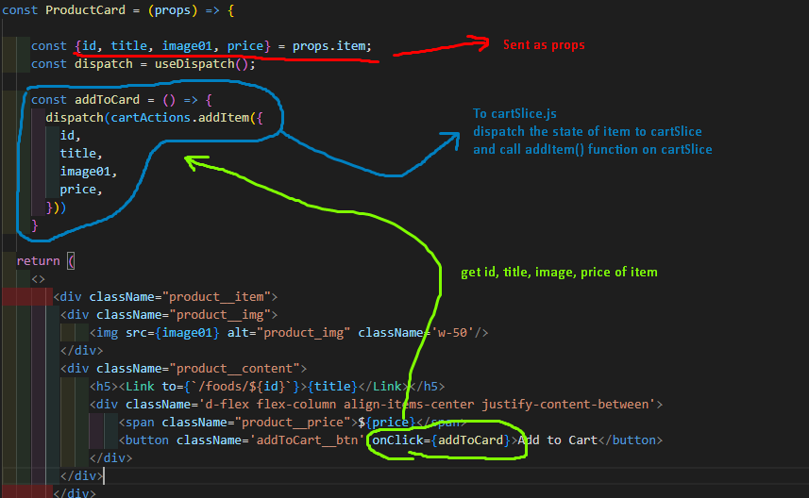

**To fit image within the specified width and height by preserving aspect ratio:**

The CSS object-fit property is used to specify how an <img> or <video> should be resized to fit its container.This property tells the content to fill the container in a variety of ways; such as "preserve that aspect ratio" or "stretch up and take up as much space as possible".

Here is where the object-fit property comes in. The object-fit property can take one of the following values:

* fill - This is default. The image is resized to fill the given dimension. If necessary, the image will be stretched or squished to fit
* contain - The image keeps its aspect ratio, but is resized to fit within the given dimension
* cover - The image keeps its aspect ratio and fills the given dimension. The image will be clipped to fit
* none - The image is not resized
* scale-down - the image is scaled down to the smallest version of none or contain



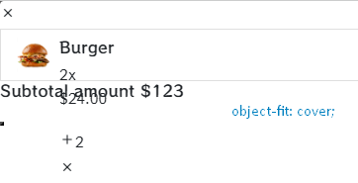.cart__item-info {

    width: 35px;

    height: 35px;

    object-fit: cover;

}

Css overflow property

<div className="cart__item-list">

              <CartItem />

</div>

.cart__item-list {

    height: calc(100vh -130px);

    overflow-y: scroll;

}

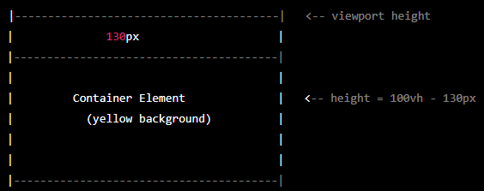Here's what the code means in practice: 100vh means 100% of the viewport height. In other words, the height of the container element will be set to be equal to the height of the browser window. -130px means we're subtracting 130 pixels from the viewport height. So, if the viewport height is 800 pixels, then the height of the container element will be set to 670 pixels (800 - 130). Here's a visual representation of how this code works: image In this example, we have a container element with a yellow background color. The viewport height is represented by the blue rectangle. The value of calc(100vh -130px) means that the container element's height will be set to the height of the viewport, minus 130 pixels. As you can see, the container element takes up 670 pixels of the viewport height, while leaving 130 pixels at the bottom of the viewport. This can be useful for ensuring that important content is always visible, even when the user scrolls down the page.

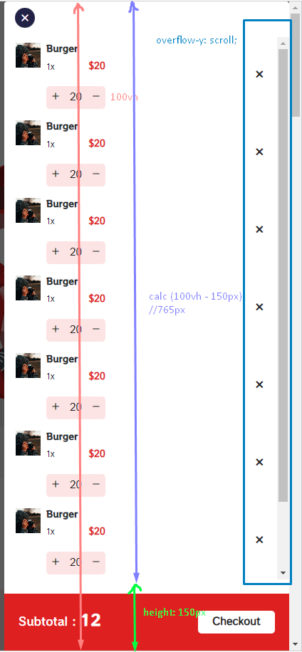 The CSS overflow property controls what happens to content that is too big to fit into an area. The overflow property specifies whether to clip the content or to add scrollbars when the content of an element is too big to fit in the specified area.

The overflow property has the following values:

visible - Default. The overflow is not clipped. The content renders outside the element's box

hidden - The overflow is clipped, and the rest of the content will be invisible

scroll - The overflow is clipped, and a scrollbar is added to see the rest of the content

auto - Similar to scroll, but it adds scrollbars only when necessary

**Sending toggle data using UseSelector and useDispatch in React Redux**

1. First define listener for both state and action using createSlice which has action function of toggle();

import { createSlice } from "@reduxjs/toolkit";

import cartSlice from "./cartSlice";

const cartUiSlice = createSlice({

    name: 'cartUi',

    initialState: {cartIsVisible: false},

    reducers: {

        toggle(state) {

            state.cartIsVisible = !state.cartIsVisible

        }

    }

})

export const cartUiActions = cartUiSlice.actions;

export default cartUiSlice;

1. Define toggle action on store as a reducer

Store.js

import { configureStore } from '@reduxjs/toolkit';

import cartSlice from './shoppingCart/cartSlice';

import cartUiSlice from './shoppingCart/cartUiSlice';

const store = configureStore({

    reducer: {

        cart: cartSlice.reducer,

        cartUi: cartUiSlice.reducer,

    }

})

export default store;

1. Pass component data through other components

Header.js

import { useSelector, useDispatch } from 'react-redux';

const Header = () => {

    const dispatch = useDispatch();

const toggleCart = () => {

        dispatch(cartUiActions.toggle())

    }

<span className="cart__icon" onClick={toggleCart}>

}

1. Store and monitor data using useDispatch()

Product.js

import { useSelector } from 'react-redux';

const Layout = () => {

const showCart = useSelector(state => state.cartUi.cartIsVisible)

  return (

    <>

            {

              showCart && <Cart />

}

)



useSelector() and useDispatch() are both hooks provided by the React Redux library for managing state in a Redux application.

useSelector() is a hook that allows you to extract data from the Redux store state. You can use it to select a specific part of the state that you want to use in your component. Whenever the selected part of the state changes, the component will re-render to reflect the updated state. Here's an example of how useSelector() works:

import { useSelector } from 'react-redux'

function MyComponent() {

  const counter = useSelector(state => state.counter)

  return (

    <div>

      <p>Counter: {counter}</p>

    </div>

  )

}

useSelector() is used to select the counter value from the Redux store state. The counter value will be used in the component to display the current value of the counter.

useDispatch() is a hook that allows you to dispatch actions to the Redux store. You can use it to trigger state changes in the Redux store. Here's an example of how useDispatch() works:

import { useDispatch } from 'react-redux'

import { increment } from './actions'

function MyComponent() {

  const dispatch = useDispatch(

  const handleClick = () => {

    dispatch(increment())

  }

  return (

    <div>

      <button onClick={handleClick}>Increment</button>

    </div>

  )

}

useDispatch() is used to create a dispatch function that can be used to dispatch the increment action to the Redux store. The increment action will trigger a state change in the Redux store, updating the counter value.

In summary, useSelector() is used to extract data from the Redux store state, while useDispatch() is used to trigger state changes in the Redux store by dispatching actions.

1. Similarly using useDispatch() to toggle the reducer action state value

import CartItem from "./CartItem";

import { cartUiActions } from "../../../store/shoppingCart/cartUiSlice";

const Carts = () => {

    const dispatch = useDispatch();

    const toggleCart = () => {

        dispatch(

            cartUiActions.toggle()

        )

    }

return (

<span onClick={toggleCart}> )



Adding CartItem using UseSelector() and useDispatch(

1. First get item from cart (store on redux state)

import { useDispatch, useSelector } from "react-redux";

const cartProducts = useSelector( state => state.cart.cartItems) ///inside cartSlice

1. Check if items are added on redux state (cartItems) if yes display using <CartItem />

        <div className="cart__item-list">

            {

                cartProducts.length === 0 ?

                    <h6 className="text-center mt-5">No item added to cart</h6>

                        :

                    cartProducts.map((item, index) => (

                        <CartItem item={item} key={index} />

                    ))

            }

        </div>

1. Add quantity to cart



import { useDispatch } from "react-redux";

    const dispatch = useDispatch();

    const incrementItem = () => {

        dispatch(cartActions.addItem({ ///add.item on cartSlice

            id,

            title,

            price,

            image01

        }))

    }

<span className="increase__btn" onClick={incrementItem}></span>

CartSlice.js

reducers: {

            addItem(state, action) {

                const newItem = action.payload;

                const existingItem = state.cartItems.find(item => item.id === newItem.id)

                state.totalQuantity++;

                if(!existingItem) {

                    state.cartItems.push({

                        id:newItem.id,

                        title: newItem.title,

                        image01: newItem.image01,

                        price: newItem.price,

                        quantity: 1,

                        totalPrice: newItem.price,

                    })

                }

                else {

                    existingItem.quantity++;

                    existingItem.totalPrice = Number(existingItem.totalPrice) + Number(newItem.totalPrice)

                }

                //generates new array

                state.totalAmount = state.cartItems.reduce((total, item) => (

                    total + Number(item.price) * Number(item.quantity), 0

                ))

            },

1. Remove (Decrease) Quantity from cart

CartSlice.js

//remove Item

reducers: {

            removeItem(state,action) {

                const id = action.payload;

                const existingItem = state.cartItems.find(item => item.id === id);

                state.totalQuantity--;

                if (existingItem.quantity === 1) {

                    state.cartItems = state.cartItems.filter(item => item.id !== id);

                    //filter out all items

                }

                else {

                    existingItem.quantity--

                    existingItem.totalPrice = Number(existingItem.totalPrice) - Number(existingItem.price)

                }

                //generates new array

                state.totalAmount = state.cartItems.reduce((total, item) => (

                    total + Number(item.price) * Number(item.quantity),0

                )) },

This is a function to remove an item from a shopping cart in a Redux store, based on the action dispatched to the reducer. Here's a line-by-line breakdown of what the code does:

1. const id = action.payload; - extracts the ID of the item to be removed from the action payload.
2. const existingItem = state.cartItems.find((item) => item.id === id); - searches for the item to be removed in the array of cart items in the Redux state.
3. state.totalQuantity--; - decrements the total quantity of items in the cart, since we're removing an item.
4. if (existingItem.quantity === 1) { ... } - checks if the item to be removed has a quantity of 1. If so, it removes the item from the cartItems array using the filter method.

This if statement checks if the quantity of the item to be removed is equal to 1. If so, it means that the item should be completely removed from the cartItems array. To achieve this, the code uses the filter method on the state.cartItems array, which returns a new array with only the items that pass a certain condition. In this case, the condition is that the item's id property is not equal to the id of the item to be removed. This means that all items that don't match the ID of the item to be removed will be kept in the new array, and the item to be removed will be excluded. The resulting array, with the removed item, is then assigned back to the state.cartItems property. This means that the Redux store's state is updated with the new cartItems array that doesn't include the removed item. So, if an item with a quantity of 1 is removed from the cart, it will be completely removed from the cartItems array in the Redux store, and the cartItems array will be updated to reflect this change.

1. else { ... } - if the item to be removed has a quantity greater than 1, it decrements the item's quantity and updates its total price.
2. After if and else part, a new array is formed (made) and rest of the operations are performed on that new array.
3. state.totalAmount = state.cartItems.reduce(...) - recalculates the total amount of the cart by multiplying each item's price by its quantity, and adding them all up.
4. setItemFunc(...) - calls a setItemFunc function with the updated cart items, total amount and total quantity, to store them in local storage or a similar mechanism.

const decreaseItem = () => {

    dispatch(cartActions.removeItem(id));

};

<span className="decrease__btn" onClick={decreaseItem}>



1. Delete Item

//Delete Item

reducers: {

deleteItem(state, action) {

            const id = action.payload;

            const existingItem = state.cartItems.find((item) => item.id === id);

            if (existingItem) {

                state.cartItems = state.cartItems.filter(item => item.id !== id);

                state.totalQuantity = state.totalQuantity - existingItem.quantity

            }

            //returns a new array here

            state.totalAmount = state.cartItems.reduce(

                (total, item) => total + Number(item.price) * Number(item.quantity),0); //initial should be 0

        }

    },

This code is a reducer function that handles the "deleteItem" action in a shopping cart application. It takes two parameters - the current state and the action object. The action object contains a payload which is the id of the item to be deleted from the cart. The reducer function first finds the item to be deleted by searching through the cart items array in the current state using the payload id. If the item is found, it is removed from the cartItems array using the filter method. Additionally, the quantity of the deleted item is subtracted from the totalQuantity property of the state object. The reducer then calculates the total amount of the remaining items in the cart by using the reduce method on the cartItems array. The reduce method takes two parameters - a callback function and an initial value (in this case, 0). The callback function calculates the total amount by multiplying the price and quantity of each item and adding it to the accumulator (total). Finally, the reducer function returns a new state object with the updated cartItems, totalQuantity, and totalAmount properties. It is important to note that the function does not modify the original state object, instead it returns a new state object with the updated properties.

This part of the code is inside the deleteItem reducer function, and it executes when an item needs to be deleted from the cart. The first line if (existingItem) checks whether the item to be deleted is present in the cart or not. If it exists, the rest of the code inside this if block is executed. The second line state.cartItems = state.cartItems.filter(item => item.id !== id); removes the item with the given id from the cartItems array. This is achieved by using the filter() method on the cartItems array, which returns a new array containing only those items that satisfy the given condition - in this case, where the id of the item is not equal to the given id. The third line state.totalQuantity = state.totalQuantity - existingItem.quantity updates the totalQuantity property of the state by subtracting the quantity of the item that was deleted from the existingItem object. This is done to keep track of the total number of items in the cart after an item has been deleted. In summary, this part of the code removes the item from the cartItems array and updates the totalQuantity property of the state object to reflect the changes made.

import { useDispatch } from "react-redux";

import { cartActions } from "../../../store/shoppingCart/cartSlice";

    const deleteItem = () => {

        dispatch(cartActions.deleteItem(id));

    };

<span className="delete__btn" onClick={deleteItem}></span>



1. Update total using useSelector()

import { cartUiActions } from "../../../store/shoppingCart/cartUiSlice";

const totalAmount = useSelector((state) => state.cart.totalAmount); ///show total

Subtotal : <span>${totalAmount}</span>

**To filter data and then map the data**

filters an array of productData based on a search term entered by the user, and then maps the filtered results to a list of ProductCard components.

 productData

                ?.filter(item => {

                  if (searchTerm.value === "") return item;

                  if (item.title.toLowerCase().includes(searchTerm.toLowerCase())) return item

                })

                .map(item =>

                  <Col lg='3' md='4' sm='6' xd='6' key={item.id}>

                    <ProductCard item = {item} /> </Col>

Here is a breakdown of how the code works:

* productData is an array of objects that represents a list of products with their details.
* The filter() method is used to filter the productData array based on a search term. The filter function takes an item from the array as an argument and returns either true or false depending on whether the item should be included in the filtered result.
* The first if statement checks whether the search term is empty. If it is, it returns the item as is, i.e., without filtering it out.
* The second if statement checks whether the title property of the item includes the search term. If it does, it returns the item to be included in the filtered result.
* The map() method is then used to create a list of ProductCard components, one for each item in the filtered result. The item object is passed as a prop to each ProductCard.
* Overall, this code provides a simple way to search and filter an array of products based on a search term entered by the user, and then display the filtered results as a list of ProductCard components.
* Thanks to Optional Chaining, inserting a ? between the property name and the period between the next property. With that, it will just return undefined instead of throwing an ugly error.



**Add Pagination to the page**

#npm i react-paginate

  import ReactPaginate from 'react-paginate';

  const [ pageNumber, setPageNumber ] = useState(0);

  const productPerPage = 8;

  const lastPage = pageNumber * productPerPage;

  const displayPage = products.slice(lastPage, lastPage + productPerPage);

  const pageCount = Math.ceil(products.length/productPerPage);

  const changePage = ({selected}) => {

    setPageNumber(selected);  }

<ReactPaginate

                  pageCount={pageCount}

                  onPageChange={changePage}

                  previousLabel='Prev'

                  nextLabel='Next'

                  containerClassName='paginationButtons'

                />

Here is a breakdown of how the code works:

* The useState hook is used to maintain the current page number. This is done by defining a state variable currentpageNumber and a function setCurrentPageNumber to update its value.
* The productPerPage variable defines the maximum number of products to display on a single page.
* The lastPostPage variable calculates the index of the last product to display on the current page. This is done by multiplying the current page number (currentpageNumber) by the number of products per page (productPerPage).
  + Initally current page is 0
  + Lastpost of the page be 0*8 = 0
    - If page is 1
    - Lastpost of page be 1*8 = 8
* The displayPage variable uses the slice method to extract the subset of products that should be displayed on the current page. The slice method is called on the products array, passing in the lastPostPage index as the starting point and the sum of lastPostPage and productPerPage as the end point. This creates a new array that contains only the products that should be displayed on the current page.
  + No of page display at 1 be “productPerPage” = products.slice(0,8)

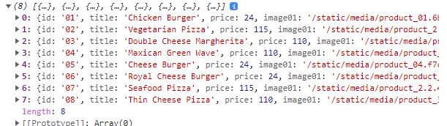

* + No of page display at 2 be = product.slice(8, (8+8))

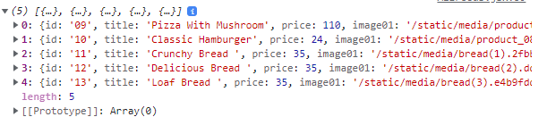

* The pageCount variable calculates the total number of pages required to display all the products in the products array. This is done by dividing the length of the products array by the productPerPage value and rounding up using the Math.ceil method. This ensures that any partial pages are accounted for and that the total number of pages is always an integer.
* The changePage function is called whenever the user clicks on a pagination link. This function updates the currentpageNumber state variable using the setCurrentPageNumber function, passing in the new page number as the argument. The selected parameter of the changePage function is passed by the pagination library and represents the new page number that the user has selected.
* The ReactPaginate component is rendered with props including pageCount, onPageChange, previousLabel, nextLabel, and containerClassName. These props are used to configure the pagination component to display the correct number of pages, update the page number when the user clicks on a link, and style the pagination buttons